**SC20F Physics Worksheet: Graphs Name:**

1. For the following d-t graph, identify which line(s) represent an object that is:

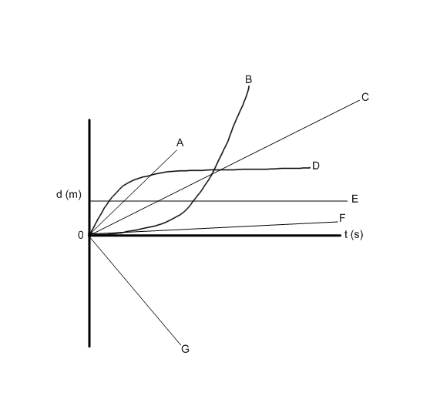

* 1. Going the fastest
  2. Going the farthest
  3. Going the slowest
  4. Not moving
  5. Speeding up
  6. Slowing down
  7. Moving backwards

1. For the following v-t graph, identify the which line(s) represent an object that is:
   1. 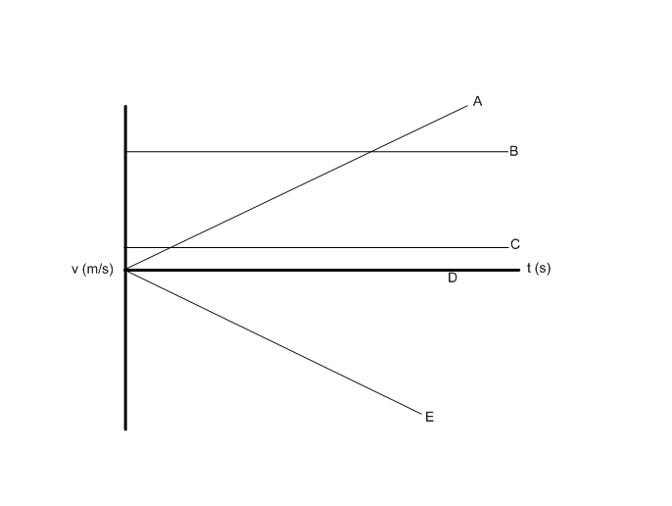Going the fastest
   2. Going the slowest
   3. Speeding up forwards
   4. Speeding up backwards
   5. Not moving
   6. Going at a constant velocity
2. For the following graph, plot a d-t graph (distance on the vertical axis and time on the horizontal).



|  |  |
| --- | --- |
| **Time (s)** | **Distance (m)** |
| 0 | 0 |
| 1 | 2 |
| 2 | 4 |
| 3 | 6 |
| 4 | 8 |
| 5 | 10 |

1. What does the slope of the line tell you?
2. Calculate the slope of the line.
3. For the following graph, plot a v-t graph (velocity on the vertical axis and time on the horizontal).



|  |  |
| --- | --- |
| **Time (s)** | **Velocity (m/s)** |
| 0 | 8 |
| 1 | 6 |
| 2 | 4 |
| 3 | 2 |
| 4 | 0 |
| 5 | -2 |

1. What does the slope of the line tell you?
2. Calculate the slope of the line.