SC20F Physics Review Assignment 1 Name:

- Marty rides his hoverboard 20km west, then 15km east, then 20km west. Determine:
  - The distance Marty travelled. (1 mark)

  - Marty’s displacement. (1 mark)

- If it took Marty 1.5 hours to complete the trip in #1, determine his:
  - Average speed. (1 mark)

  - Average velocity (1 mark)

- A cyclist starts from rest (0m/s) and speeds up to +10m/s in 2 seconds. Determine the acceleration of the cyclist. (2 marks)

- On the ticker tapes below, draw a set of dots showing each of the following situations:
(3 marks)
  - An object moving at constant speed

  - An object speeding up

  - An object slowing down

- Given the following scenarios, answer the questions:
Scenario A

- For the graphic above, describe the motion that the van has. (1 mark)

- What is the sign of the velocity? (0.5 marks)

- What is the sign of the acceleration? (0.5 marks)

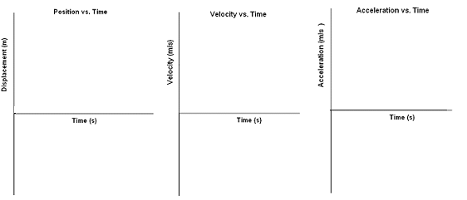
- Sketch the lines for the Position-Time graph, the Velocity-Time graph, and the Acceleration-Time graph that describe this motion. (1.5 marks)

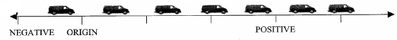
Scenario B

- For the graphic above, describe the motion that the van has. (1 mark)

- What is the sign of the velocity? (0.5 marks)

- What is the sign of the acceleration? (0.5 marks)

- Sketch the lines for the Position-Time graph, the Velocity-Time graph, and the Acceleration-Time graph that describe this motion. (1.5 marks)

- State Newtons 1st law. (1 mark)

- Why do you lunge forward when your car suddenly comes to a halt? (1 mark)

- State whether the forces are balanced or unbalanced in the following situations: (2 marks)
  - An object is not moving.

  - A car is speeding up to pass someone on the highway.

  - A plane is travelling at a constant speed of 400km/hr

  - A truck is slowing down to stop for a red light.

- You are at a restaurant, and your friend is trying to get the ketchup out of the bottle. He is hitting the back of the bottle, trying to force the ketchup out. Use Newton’s first law to explain to her why this is not the best way.

