SC20F Distance & Displacement Quiz Name:

- Define Scalar and Vector.

a) Scalar

b) Vector

- Identify the following as scalar or vector:

a) Distance b) Displacement

c) Speed d) Velocity

- Identify the following as either a distance or a displacement:

a) 30 m b) 100 yds

c) 5 km [N] d) 0.9 mi [W]

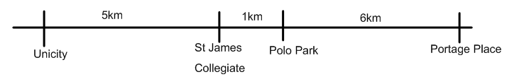

- John thinks Jouquin is SUPER cool cause he LOVES One Direction, so he jumps on the “band”wagon and decides he should wallpaper his room in 1-D posters. He leaves school and heads to unicity to buy as many 1-D posters as he can. From unicity, he heads to portage place and buys them all up there. He goes to check the 1-D fanclub twitter feed, but realizes he left his phone at school. He heads to school to get his phone, then goes to polo park to load up on more posters.

a) what is John's distance travelled?

b) what is John's displacement?

