Chem40 Exam Review Key

Aqueous Reactions

- H₂SO₄(aq) 2H⁺(aq) + SO₄²⁻(aq)
Sulfuric acid is a strong electrolyte because it dissociates completely into ions. You could prove this by using a conductivity test, or measuring the pH.

- a) Mg(OH)₂(aq) + HBr(aq) MgBr₂(aq) + H₂O
b) H₃PO₄(aq) + NaOH(aq) Na₃PO₄(aq) + H₂O
c) H₂SO₄(aq) + Al(OH)₃(aq) Al₂(SO₄)₃(aq) + H₂O

- 0.365 mol/L

- 0.125L H₂O

- 0.125 L H₂SO₄

- 0.0125 L H₂SO₄

- 78.1 mL Mg(OH)₂

- 4.818g Ba(OH)₂

- 0.648 mol/L H₂SO₄

- Increasing temperature increases the kinetic energy of the solid and water particles, allowing more molecules to overcome the intermolecular forces and separate (or dissociate if an ionic compound)

- a) Na₂SO₄(s) 2Na⁺(aq) + SO₄²⁻(aq)
b) CuSO₃(s) low solubility in water
c) Na₂C₂O₄(s) 2Na⁺(aq) + C₂O₄²⁻(aq)
d) Mg(NO₃)₂(aq) Mg²⁺(aq) + 2NO₃⁻(aq)

- a) CrCl₂ – soluble
b) MgCO₃ – low solubility
c) Ag₂S - low solubility
d) (NH₄)₃PO₄ – soluble
e) Al(OH)₃ – low solubility
f) NaHCO₃ – soluble

- a) Pb(NO₃)₂(aq) + KCl(aq) PbCl₂(s) + KNO₃(aq)
b) Al₂(SO₄)₃(aq) + BaBr₂(aq) AlBr₃(aq) + BaSO₄(s)
c) HgNO₃(aq) + KCl KNO₃(aq) + HgCl(aq) (***not using Hg²⁺)
d) FeCl₃(aq) + NaOH(aq) NaCl(aq) + Fe(OH)₃(s)

- a) +4 -2 +1 -1 +2 -1 0 +1 +2
MnO₂ + 4HCl MnCl₂ + Cl₂ + 2H₂O

Cl is oxidized (2Cl Cl₂ + 2e⁻)
Mn is reduced (Mn + 2e⁻ Mn)

MnO₂ is the oxidizing agent
HCl is the reducing agent

b) +3 -2 +1 -2 -2 +1 +6 -2 -1 +1 -2
2CrO₂⁻ + 3ClO⁻ + 2OH⁻ 2CrO₄²⁻ + 3Cl⁻ + H₂O

Cr is oxidized (Cr Cr + 3e-)
Cl is reduced (Cl Cl⁻ + 2e⁻)

ClO⁻ is the oxidizing agent
CrO₂⁻ is the reducing agent

- a) H₂O + MnO₄⁻ + 5VO²⁺ 5VO₂⁺ + Mn²⁺ 2H⁺
b) 12H₂O + 12OH⁻ + 4P₄ 4PH₃ + 12H₂PO₂⁻
c) H₂O + MnO₂ + SO₃²⁻ SO₄²⁻ + Mn(OH)₂
d) 6H⁺ + 2MnO₄⁻ + 5H₂O₂ 2Mn²⁺ + 5O₂ + 8H₂O
e) 9H⁺ + 2Mn²⁺ + 5HBiO₃ 5Bi³⁺ + 2MnO₄⁻ + 7H₂O
f) *** question should have read Zn + H₂O Zn(OH)₄²⁻ + H₂
answer: 2OH⁻ + Zn + H₂O Zn(OH)₄²⁻ + H₂

Atomic Structure
- As wavelength increases, frequency decreases and energy decreases.

- Both contain different colours. Continuous has each colour blending into the next (ie. No distinct colour). Line spectra have discreet wavelengths of light that are separate.

- When burned, elements will emit a specific set of wavlengths of light (a line spectrum). The blending of the colours in the line spectrum will cause the colour produced. Each element produces different line spectra because electrons can only jump between specific energy levels.

When an electron absorbs energy, it “jumps” to a higher energy level. As it falls back to the ground state, it releases energy in the form of light, u.v radiation, etc. The wavelength and energy released depends on the distance between energy levels.

- See notes.

Orbital Type | Number of Orbitals | Energy Levels
s | 1 | 1 and up
p | 3 | 2 and up
d | 5 | 3 and up
f | 7 | 4 and up

- “n” represents the principle quantum number (energy level)

- n² = # of electron orbitals.
  - n=1 1 orbital
  - n=2 4 orbitals
  - n=3 9 orbitals
  - n=4 16 orbitals
  - n=5 25 orbitals

- Krypton has 18 electrons, and a configuration of 1s²2s²2p⁶3s²3p⁶4s²3d¹⁰4p⁶. Ions that would have the same configuration would be As³⁻, Se²⁻, Br¹⁻, In³⁺, Sr²⁺, Rb¹⁺

- Electron designations:
  - 7
  - 3
  - 2
  - 3² = 9 orbitals x 2e-/orbital = 18 electrons.

- Complete Configurations:
  - 1s²2s²2p⁶3s²3p⁶4s¹
  - 1s²2s²2p⁶3s²3p⁶
  - 1s²2s²2p⁶3s²3p⁶4s²3d⁴
  - 1s²2s²2p¹3s²3p⁵
  - 1s²2s²2p¹3s²3p²
  - 1s²2s²2p⁶3s²3p⁶4s¹3d⁹

- Valence Configurations:
  - 3s²3p³
  - 6s²6p²
  - 4s²
  - 4s²4p⁵

- Unpaired Electrons
  - 2
  - 2
  - 0
  - 1

- Noble Gas Configurations:
- [Ne]3s²3p⁵
- [Ar]4s²3d¹⁰4p⁴
- [Ne]3s¹
- [Ar]4s²3d⁷

- Polar molecules have slight opposite charges on each side of the molecule due to uneven sharing of electrons. Caused by differences in E-neg.

- Bond Character:
  - Polar
  - Non- Polar Covalent
  - Polar

- a) Electronegativity:
- Increases across a row
      - More protons in the nucleus, so more nuclear charge.
      - Electrons are filling the same energy level, so same distance and shielding, so more nuclear force pulling on electrons
      - Therefore atom will attract electrons more.

- Decreases down a column
      - Every row is filling another energy level. Valence electrons are further away and have more shielding.
      - Even though there are more protons as you go down the column, the increased distance and shielding mean that less force is felt by valence electrons.
      - Therefore the atom will attract electrons less.

b) Atomic Radius:
- Decreases across a row
      - More protons in the nucleus, so more nuclear charge.
      - Electrons are filling the same energy level, so same distance and shielding, so more nuclear force pulling on electrons
      - Therefore outer electrons are pulled in tighter, making atom smaller.

- Increases down a column
      - Every row is filling another energy level. Valence electrons are further away and have more shielding.
      - Even though there are more protons as you go down the column, the increased distance and shielding mean that less force is felt by valence electrons.
      - Therefore outer electrons are allowed to move more freely, and atom gets bigger.

Kinetics

- Nature of reactants
Temperature
Concentration
Surface area (solids only)
Pressure (gases only)
Catalysts

- In order for a chemical reaction to occur, the recting particles (molecules, ions, atoms) must collide with each other.

- Reaction rate depends on particles colliding with the correct orientation, the appropriate proportion, and sufficient energy.

- The steps in which a reaction occurs.

- The slowest step of all the step in a reaction.

- number of bonds broken (the fewer, the faster)
type of bonds broken (aqueous ionic fast / covalent slower)
state/phase of reactants (gas faster than liquids / liquids faster than solid)

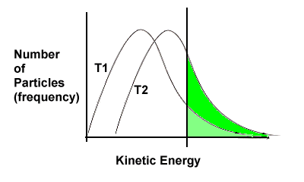
T2 (higher temperature) = higher % of particles with enough kinetic energy to react (energy equal to, or greater than, the activation energy)

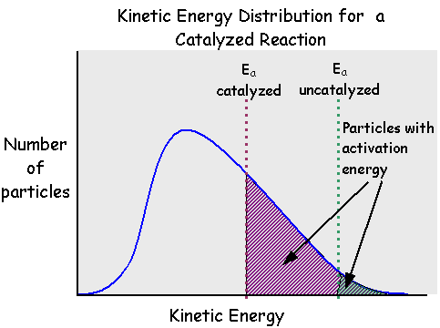

Catalysts lower the activation energy, resulting in more particles having enough activation energy to react.

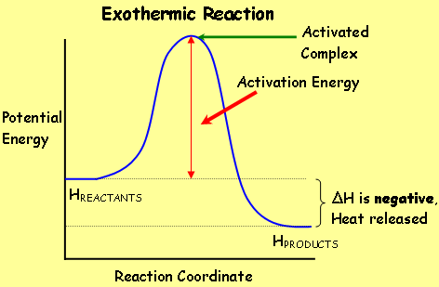

kJ/mol reactants

kJ/mol products

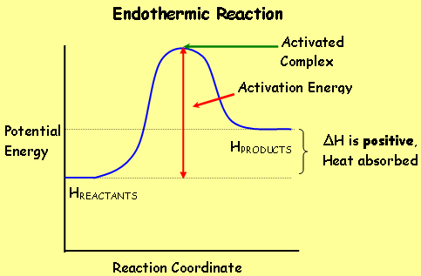

- 6.173 x 10⁻⁵ M/s

- a) Rate = k[NO]²[Cl₂]
b) overall order = 3rd order
c) k = 120

- *** not sure if the graph actually printed, but if it did the answer is $≅$-1.5 M/s

- Rate is the change in the concentration of a substance over time
Rate = $\frac{∆[ ]}{∆t}$

- Rate_{A} = 2.5 x 10⁻³ M/s
Rate_{B} = 3.75 x 10⁻³ M/s
Rate_{C} = 1.25 x 10⁻³ M/s
Rate_{D} = 2.5 x 10⁻³ M/s

- a) Rate_{20-40s} = 0.85 M/s
Rate_{40-60s} = 0.002 M/s
b) *** Question has a typo (“17.00” is a mistake) making graphing very cumbersome
c) would calculate the slope of the tangent line drawn at 40s

- a) Rate = k[A]⁰ (or, Rate = k)
b) Rate = k[A]¹
c) Rate = k[A]²

- a) [A]¹ , [B]² , [C]⁰
b) Rate = k[A]¹[B]²
c) k = 4.724 x 10⁻⁵
d) rate = 0.0378 M/s

- omit question

Chemical Equilibrium

- There can be two types of equilibrium – physical and chemical. Both equilibria must occur in a closed system with constant temperature. When equilibrium occurs there is no macroscopic changes but there is still activity at the particle level. In physical equilibrium the rates between two phase changes become equal. In chemical equilibrium the rates between the forward and reverse reactions become equal.

- “If a stress is imposed on a system at equilibrium, the position of the equilibrium will shift in a direction that tends to reduce the stress”. In other words, whatever you do to a system at equilibrium, the system will do the opposite to reduce the stress.

- a) Increasing the temperature of an exothermic reaction will cause the reaction to shift left, and cause an endothermic reaction to shift right. Decreasing the temperature would cause the opposite.
b) Increasing the concentration of the reactants will cause the reaction to shift right. Increasing the concentration of the products will cause the reaction to shift left. Decreasing the concentration would cause the opposite.
c) Increasing the pressure will cause the reaction to shift to whatever side has the least number of gas particles. Decreasing the pressure will cause the reaction to shift to whatever side has the most number of gas particles. If gas particles are equal on both sides of the reaction, then changing pressure has no effect. Pressure change only affects a reaction if there are reactants or products in the gas phase.
d) Catalysts have no effect on equilibrium (except for a reaction to get to equilibrium faster)

- a) K_{eq} = [O₂] [N₂O₄]²
[N₂O₅]²

b) K_{eq} = [Bi³⁺] [H₂S]³
[H⁺]⁶

- a) At equilibrium; [H₂]=3.22M, [CO₂]=3.22M, [H₂O]=0.78
b) K_{eq} = 0.059

- 1.55M

- a) No, system is not at equilibrium (too many products).
- Reaction needs to shift left to get to equilibrium.

- A = B = 0.667 mol ; C = D = 1.333 mol

- a) shift right
b) shift right
c) shift left
d) shift left
e) no shift
f) shift left

- a)
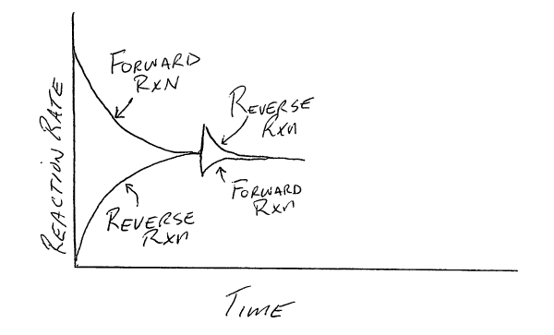

b)
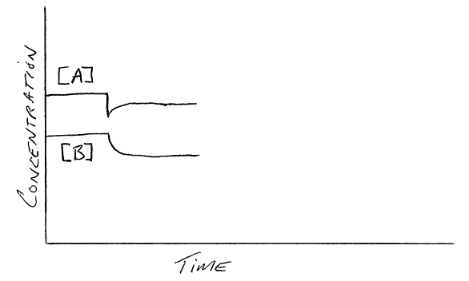

- [A] = [B] = 0.36M; [C] = 2.28M

- a) shift right
b) shift left
c) shift right
d) shift right
- a) K_{sp} = [Pb²⁺] [SO₄²⁻]
b) K_{sp} = [Mg²⁺] [ OH⁻]²

- a) Ag₃PO₄ 3Ag⁺ + PO₄³⁻
K_{sp} = [Ag⁺]³ [PO₄³⁻]

b) Al₂(CO₃)₃ 2Al³⁺ + 3CO₃²⁻
K_{sp} = [Al³⁺]² [CO₃²⁻]³

- a) 9.327 x 10⁻⁵ mol/L
b) 9.336 x 10⁻⁴ g

- K_{sp} = 1.332 x 10⁻⁸

- K_{sp} = 5.25 x 10⁻⁸

- K_{sp} = 3.68 x 10⁻¹⁵

- a) 1.05 x 10⁻⁵ mol BaSO₄
b) [Ba²⁺] = [SO₄²⁻] = 1.05 x 10⁻⁵ mol/L
c) K_{sp} = 1.10 x 10⁻¹⁰

- 7.892 x 10⁻⁴ g

- *** error in the way questions are written, ignore “Ksp=” in each question
a) K_{sp} = 1.5 x 10⁻¹⁶
b) K_{sp} = 5.157 x 10⁻¹²
c) K_{sp} = 6.912 x 10⁻¹²

- K_{sp} = 2.557 x 10⁻⁸

- a) 1.209 x 10⁻⁴
b) [Mg²⁺] = 1.209 x 10⁻⁴ , [OH⁻] = 2.418 x 10⁻⁴
c) K_{sp} = 7.066 x 10⁻¹²

Acid and Base Equilibrium

- a) Can identify by measuring pH, strong acids have a pH less than 3.
b) Can identify by measuring pH, weak base will have a pH between 7.1 and 11.
c) Can identify by measuring pH, neutral solutions will have a pH of 7.

- a) Strong acids/bases are ionic compounds that completely dissociate in water.
b) Dilute means acids/bases are mixed with a lot of water.
c) Weak acids/bases are ionic compounds that do not completely dissociate in water (an equilibrium is reached between forward and reverse reactions)
d) Concentrated means acids/bases are mixed with very little water.
- HNO₃ + H₂O H₃O⁺ + NO₃⁻

- HClO₃ + H₂O H₃O⁺ ClO₃⁻

- H₃PO₄ + H₂O H₃O⁺ + H₂PO₄⁻
H₂PO₄⁻ + H₂O H₃O⁺ + HPO₄²⁻
HPO₄²⁻ + H₂O H₃O⁺ + PO₄³⁻

or

H₃PO₄ H⁺ + H₂PO₄⁻
H₂PO₄⁻ H⁺ + HPO₄²⁻
HPO₄²⁻ H⁺ + PO₄³⁻

- a) HBr + H₂O H₃O⁺ + Br⁻
b) NH₃ + H₂O NH₄⁺ + OH⁻
CO₃²⁻ + H₂O HCO₃⁻ + OH⁻
c) Ca(OH)₂ Ca²⁺ + 2OH⁻
d) Mg + HCl MgCl₂ + H₂

- a) OH⁻
b) NO₂
c) NH₃
d) H₂PO₄

- a) HSO₄⁻
b) NH₄⁺
c) H₂PO₄⁻
d) H₂O₂

- Acids: HSO₄⁻ and HPO₄²⁻ Bases: PO₄³⁻ and SO₄²⁻

- Pair 1: Acid H₃O⁺ , conjugate base H₂O
Pair 2: Base C₂H₃O₂⁻ , conjugate acid HC₂H₃O₂

- a) F⁻ + H₂O HF + OH⁻
b) NO₂⁻ + H₂O HNO₂ + OH⁻
c) LiOH Li⁺ + OH⁻

- Pair 1: Acid HSO₄⁻ , conjugate base SO₄²⁻
Pair 2: Base HCO₃⁻ , conjugate acid H₂CO₃

- a) CO₃²⁻
b) CN⁻
c) H₄IO₆⁻
d) NH₃

- NH₃ + H₂O NH₄⁺ + OH⁻

- HClO₄, HNO₂, H₂S, NH₃

- NH₂, OH⁻, CO₃²⁻, HCO₃⁻, Cl⁻

- 0.012 mol/L of OH⁻

- a) K_{a} = [H₃O⁺] [NO₂⁻]
[HNO₃]
b) K_{a} = [H₃O⁺] [HCO₃⁻]
[H₂CO₃]
c) K_{a} = [H₃O⁺] [PO₄³⁻]
[HPO₄²⁻]

- a) H₃PO₄ + HS⁻ H₂PO₄⁻ + H₂S
B B
Products favoured (forward rxn favoured)

b) HSO₃⁻ + NH₄⁺ SO₃²⁻ + NH₅²⁺
B B
Reactants favoured (reverse rxn favoured)

c) HPO₄²⁻ + HCO₃⁻ H₂PO₄⁻ + CO₃²⁻
B B
Reactants favoured (reverse rxn favoured)

d) Al(H₂O)₆³⁺ + HTe⁻ Al(H₂O)₅(OH)²⁺ + H₂Te
B B
Reactants favoured (reverse rxn favoured)

- ***error in ionic charge of H₂PO₄, should be H₂PO₄⁻ (not ²⁻)
a) H2PO4- + H2O H3O+ + HPO42-
b) H2PO4- + H20 H3PO4 + OH

- H₂S + NH₃ NH₄⁺ + HS⁻
a) H₂S
b) NH₃ and HS⁻
c) products favoured (forward rxn favoured)

- [H₃O⁺] decreases because rxn shifts left

- HBb + H₂O H₃O⁺ + Bb⁻
yellow blue

- NH₃ + H₂O NH₄⁺ + OH⁻
Adding NH₄Cl causes the rxn to shift left, [OH⁻] decreases,
therefore [H₃O⁺] increases

- HMo + H₂O H₃O⁺ + Mo⁻
yellow red

a) KOH will cause the indicator’s reaction to shift right since adding OH- will react with the H3O+ (resulting in a decreasing stress on H3O+) and cause the solution to become red.
b) H3PO4 will cause the indicator’s reaction to shift left since adding H3PO4 will be an increasing stress on H3O+, and cause the solution to become yellow
- 2H₂O H₃O⁺ + OH⁻
a) [H₃O⁺] increases, [OH⁻] decreases
b) [H₃O⁺] increases, [OH⁻] decreases

- a) B⁻ and X⁻
b) B⁻
c) HB
d) large value
e) shift right / forward rxn increases

- pH = 7.14

- a) [H⁺] = 1.41 x 10⁻⁴, acidic
b) [H⁺] = 2.45 x 10⁻¹², basic
c) [H⁺] = 7.76 x 10⁻⁵, acidic
d) [H⁺] = 5.01 x 10⁻⁹, basic

- [H⁺] = 0.0012 mol/L, pH = 2.93

- pH = 2.30

- % dissociation = 6.67%, pH = 2

- % dissociation = 0.79%, pH = 3.10

- [H₃O⁺] = 4.382 x 10⁻⁴, pH = 3.36

- K_{a} = 3.18 x 10⁻⁴

- K_{a} = 3.98 x 10⁻⁸

- a) [Y⁻] = 0.0005M
b) K_{a} = 2.5 x 10⁻⁶
c) pH = 3.30
d) [OH⁻] = 2 x 10⁻¹¹

- [H₃O⁺] = 3.12 x 10⁻³, [OH⁻] = 3.21 x 10⁻¹², pH = 2.5

- % dissociation = 6.31%, K_{a} = 4.25 x 10⁻⁴

- [HBrO] = 0.126 mol/L

- a) pH = 2
b) pH = 2.52
c) pH = 13.7
d) pH = 13

Oxidation-Reduction

- a) 3Ni²⁺ + 2Al 3Ni + 2Al³⁺ spontaneous
b) not spontaneous
c) not spontaneous
d) 2Li + Zn²⁺ 2Li⁺ + Zn spontaneous

2. a) spontaneous in the forward direction
b) spontaneous in the reverse direction

- a) b) c)
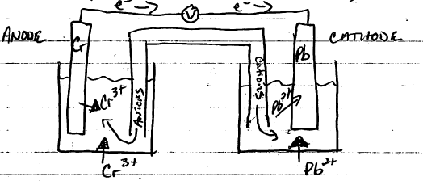

d) Anode: (Cr Cr³⁺ + 3e⁻)
Cathode: (Pb²⁺ + 2e⁻ Pb)
e) 2Cr + 3Pb²⁺ 2Cr³⁺ + 3Pb
f) Eº = +0.61V

- a) Eº = -0.08V, spontaneous in reverse direction
b) Eº = +0.24V, spontaneous in forward direction

